Guidelines for Retention of Pre-settlement (Mature and Old) Ponderosa Pine:
Every effort should be made to conserve old trees to promote a balanced, uneven-aged forest condition that maintains, or contributes to the restoration of pre-settlement old growth conditions characteristic of the forest type. This should be achieved by retaining pre-settlement trees, often the largest and tallest trees on site. All trees greater than 24” DBH will be retained on site regardless of condition or old tree characteristics, unless deemed an imminent hazard ^{[1]} to people or property.

In addition to trees >24” diameter, all trees with pre-settlement characteristics will be retained. For ponderosa pine, pre-settlement trees (≈1865) may be determined by the following characteristics described by Thomson (1940) ^{[2]} as age class 3 (intermediate to mature) and age class 4 (mature to old):

  - Age – approximately 150 years and older.
  - Bark – ranging from reddish brown, shading to black in the top with moderately large plates between the fissures to reddish brown to yellow, with very wide, long and smooth plates occupying more than 50% of the tree bole.
  - Branching – ranging from upturned in upper third of the crown, horizontal in the middle third and drooping in the lower third of the crown to mostly large, drooping, gnarled or crooked. Branch whorls range from incomplete and indistinct except at the top to completely indistinct and incomplete.

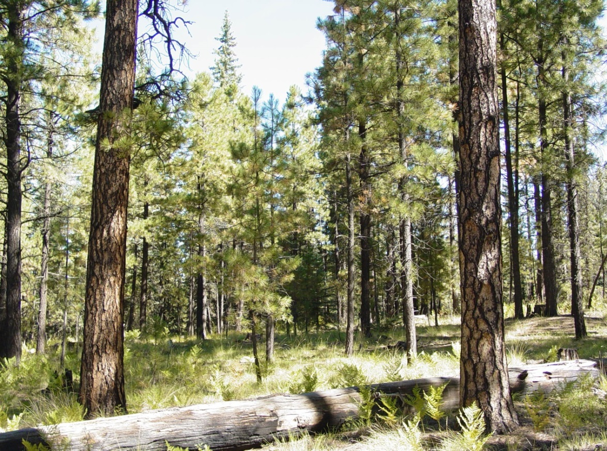
Figure 2. Bark Characteristics between young and old ponderosa pine: far left = Young, middle = Intermediate, right = Old.
Additional Characteristics to Consider for Wildlife Tree Retention and Safety:
- Favor ponderosa pine with: flat tops, large horizontal limbs, broken branches, spiked (dead) top, advanced signs of decay: trees with damage or decay in the form of lightning scars, visible rot, fire scars/cat faces or bark seams beginning at the base of the tree, or gray xylem (hardwood) with or without the presence of holes or vertical cracks. Freshly exposed xylem wood where the tree may have sealed the wound with sap is not considered advanced decay.
- Intermediate aged trees with larger, reddish brown, smooth platy bark and one or more of the above characteristics can also be good snag/wildlife recruitment trees.
- Poor form (Minimum diameter that applies to this description is 12 inches DBH): dominant multiple forks, crooks, and sweeps may be used as selection criteria to leave a tree if the tree exhibits none of the old-tree characteristics or advanced decay. The mere presence of these characteristics should not automatically determine the tree is to be left.
- Presence of nests in the tree canopy. Cavity holes, burls or conks on the tree bole.
- Evaluate trees for the presence of metal within the bole, such as fencing wire, stakes, spikes, or nails. If cutting a tree poses a safety hazard to the tree faller, it should be retained.
- Hazard trees should be removed regardless of age and size per agency protocols to prevent personal injury and property damage. Any leave tree may be felled for safety purposes, at the discretion of the contract/agreement administrator.

[1] A hazard tree is defined as a tree that has both: a structural defect that increases the chance of a tree or its parts to fail, and a target (people, buildings, cars, etc.) would be hit when the tree fails. USDA Forest Service, Southwestern Region. 2015. Tree Risk Detection and Management in the Southwestern Region.
[2] Thomson, W. G. 1940. A Growth Rate Classification of Southwestern Ponderosa Pine. Journal of Forestry. 38:547-553.

